Chapter 4: Linear Programming Applications

A Product Mix Example

Problem Definition

- Four-product T-shirt/sweatshirt manufacturing company.
- Must complete production within 72 hours
- Truck capacity = 1,200 standard sized boxes.
- Standard size box holds12 T-shirts.
- One-dozen sweatshirts box is three times size of standard box.
- $25,000 available for a production run.
- 500 dozen blank T-shirts and sweatshirts in stock.
- How many dozens (boxes) of each type of shirt to produce?

 | Processing Time (hr)  Per dozen | Cost  ($)  per dozen | Profit  ($)  per dozen
Sweatshirt - F | 0.10 | 36 | 90
Sweatshirt – B/F | 0.25 | 48 | 125
T-shirt - F | 0.08 | 25 | 45
T-shirt - B/F | 0.21 | 35 | 65

Decision Variables:
x1 = sweatshirts, front printing
x2 = sweatshirts, back and front printing
x3 = T-shirts, front printing
x4 = T-shirts, back and front printing
Objective Function:
Maximize Z = $90x1 + $125x2 + $45x3 + $65x4
Model Constraints:
0.10x1 + 0.25x2+ 0.08x3 + 0.21x4 ≤ 72 hr
3x1 + 3x2 + x3 + x4 ≤ 1,200 boxes
$36x1 + $48x2 + $25x3 + $35x4 ≤ $25,000
x1 + x2 ≤ 500 dozen sweatshirts
x3 + x4 ≤ 500 dozen T-shirts

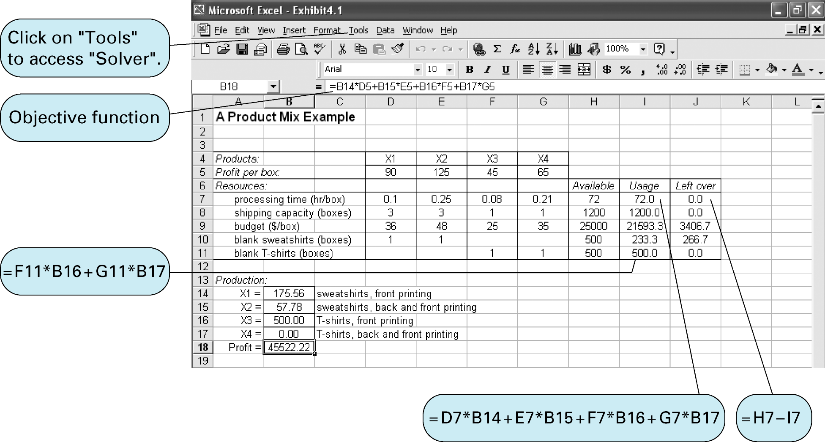

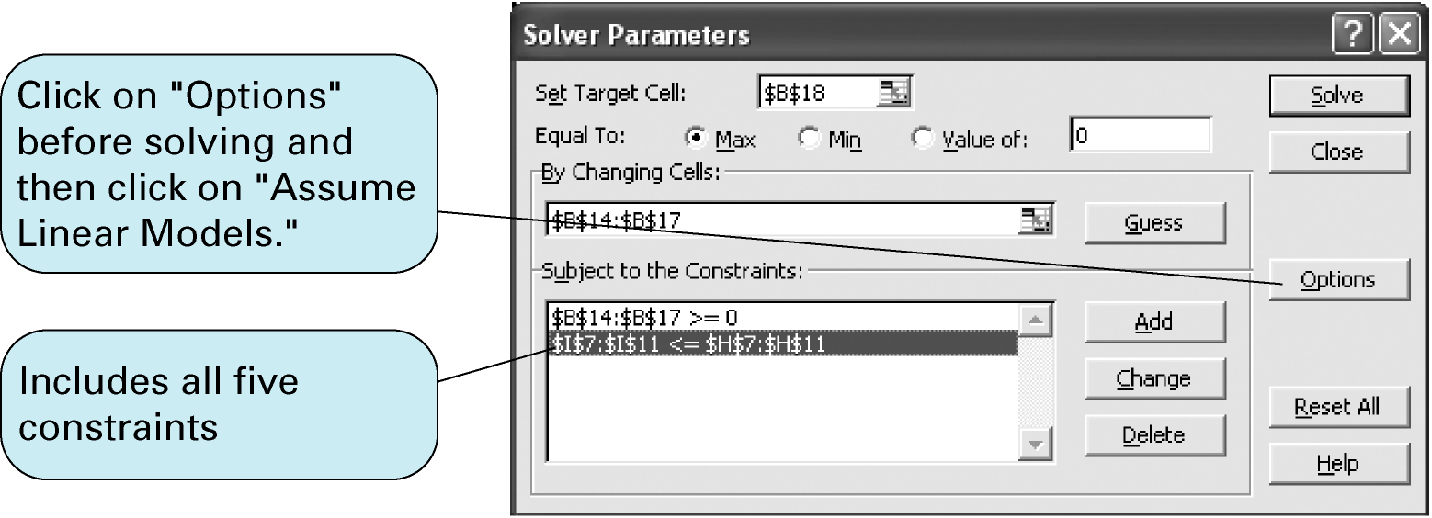

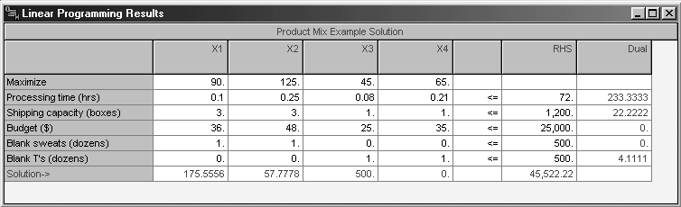

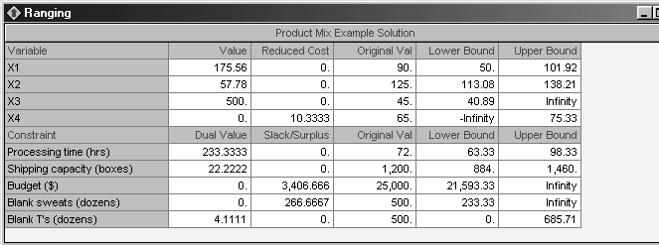

A Diet Example - Data and Problem Definition

Breakfast Food | Cal | Fat  (g) | Cholesterol  (mg) | Iron  (mg) | Calcium  (mg) | Protein  (g) |  | Fiber  (g) | Cost  ($)
- Bran cereal (cup)  - Dry cereal (cup)  - Oatmeal (cup)  - Oat bran (cup)  - Egg  - Bacon (slice)  - Orange  - Milk-2% (cup)  - Orange juice (cup)  - Wheat toast (slice) | 90  110  100  90  75  35  65  100  120  65 | 0  2  2  2  5  3  0  4  0  1 | 0  0  0  0  270  8  0  12  0  0 | 6  4  2  3  1  0  1  0  0  1 | 20  48  12  8  30  0  52  250  3  26 | 3  4  5  6  7  2  1  9  1  3 | 5  2  3  4  0  0  1  0  0  3 |  | 0.18  0.22  0.10  0.12  0.10  0.09  0.40  0.16  0.50  0.07
Breakfast to include at least 420 calories, 5 milligrams of iron, 400 milligrams of calcium, 20 grams of protein, 12 grams of fiber, and must have no more than 20 grams of fat and 30 milligrams of cholesterol.

Decision Variables:
x1 = cups of bran cereal
x2 = cups of dry cereal
x3 = cups of oatmeal
x4 = cups of oat bran
x5 = eggs
x6 = slices of bacon
x7 = oranges
x8 = cups of milk
x9 = cups of orange juice
x10 = slices of wheat toast

Minimize Z = 0.18x1 + 0.22x2 + 0.10x3 + 0.12x4 + 0.10x5 + 0.09x6 + 0.40x7 + 0.16x8 + 0.50x9 + 0.07x10
subject to:
90x1 + 110x2 + 100x3 + 90x4 + 75x5 + 35x6 + 65x7 + 100x8 + 120x9 + 65x10 ≥ 420
2x2 + 2x3 + 2x4 + 5x5 + 3x6 + 4x8 + x10 ≤ 20
270x5 + 8x6 + 12x8 ≤ 30
6x1 + 4x2 + 2x3 + 3x4+ x5 + x7 + x10 ≥ 5
20x1 + 48x2 + 12x3 + 8x4+ 30x5 + 52x7 + 250x8
+ 3x9 + 26x10 ≥ 400
3x1 + 4x2 + 5x3 + 6x4 + 7x5 + 2x6 + x7+ 9x8+ x9 + 3x10 ≥ 20
5x1 + 2x2 + 3x3 + 4x4+ x7 + 3x10 ≥ 12 xi ≥ 0, for all j
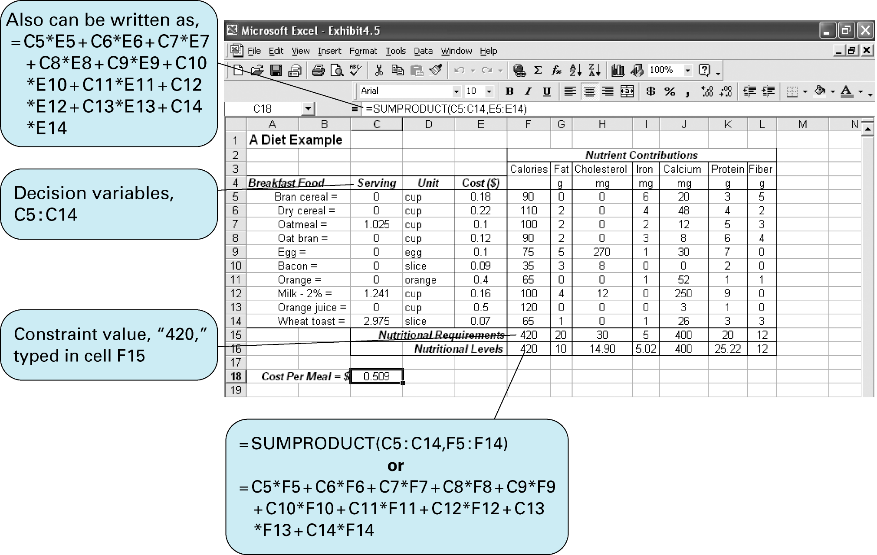

An Investment Example
Maximize Z = $0.085x1 + 0.05x2 + 0.065 x3+ 0.130x4
subject to:
x1 ≤ 14,000
x2 - x1 - x3- x4 ≤ 0
x2 + x3 ≥ 21,000
-1.2x1 + x2 + x3 - 1.2 x4 ≥ 0
x1 + x2 + x3 + x4 = 70,000
x1, x2, x3, x4 ≥ 0
where
x1 = amount invested in municipal bonds ($)
x2 = amount invested in certificates of deposit ($)
x3 = amount invested in treasury bills ($)
x4 = amount invested in growth stock fund($)
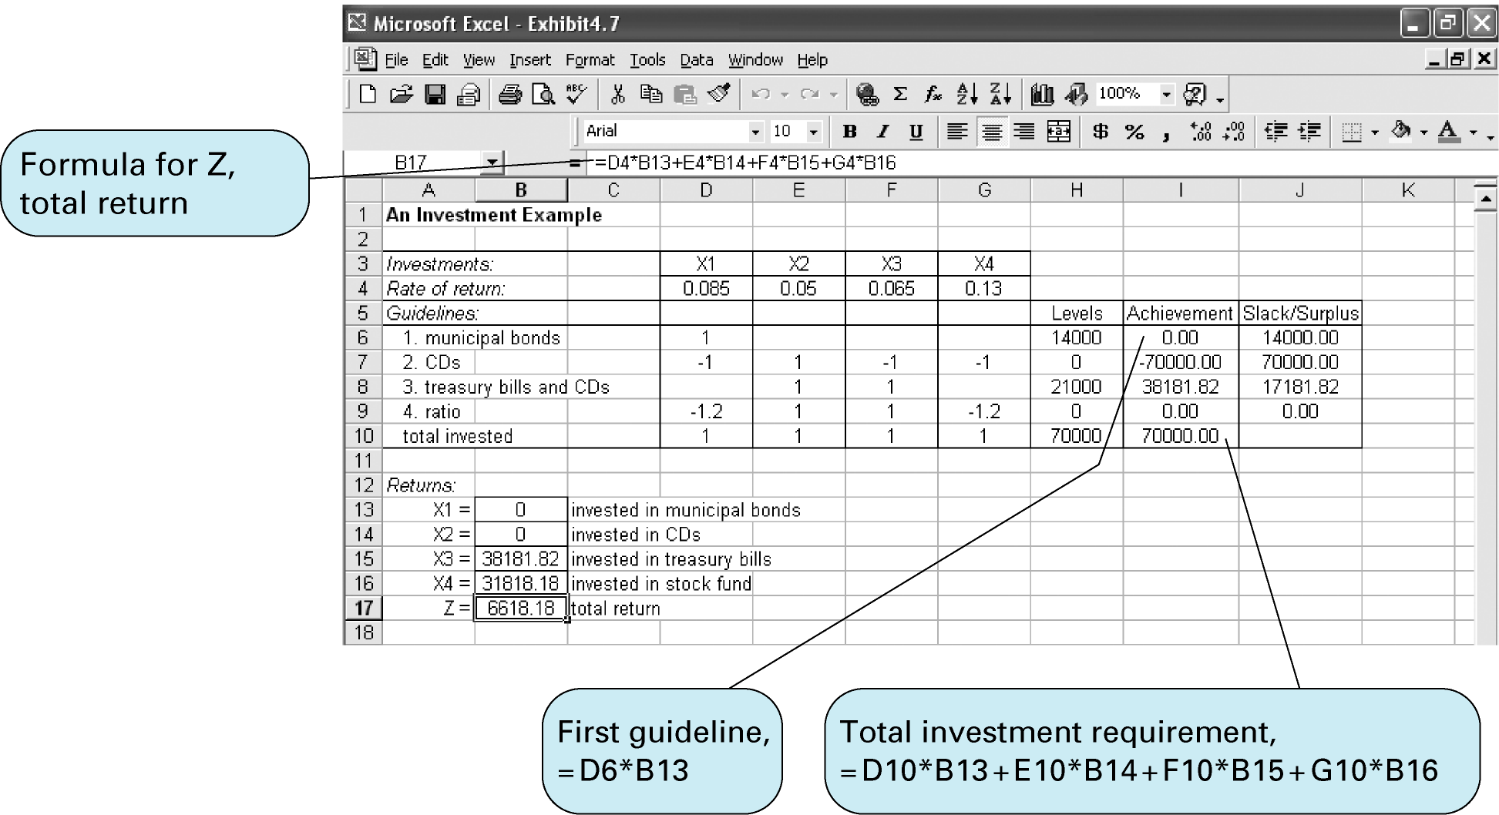

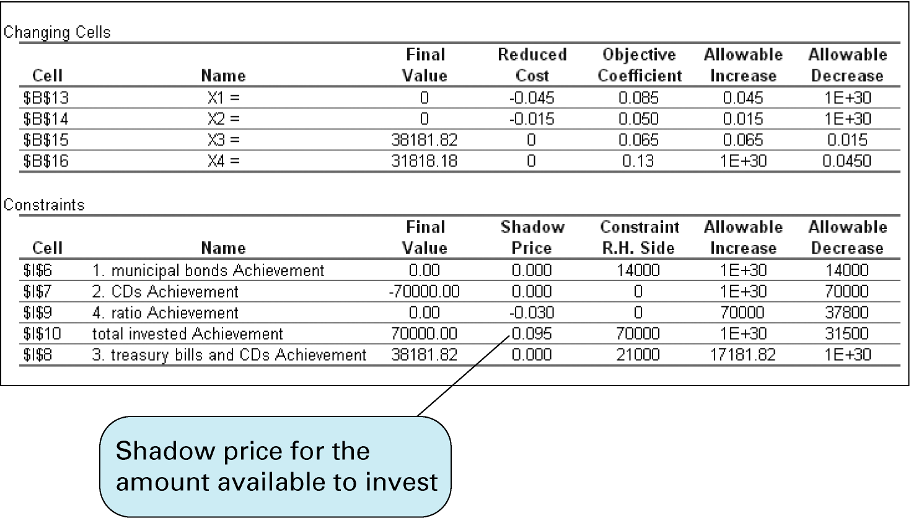

A Marketing Example

 | Exposure  (people/ad or commercial) | Cost
Television Commercial | 20,000 | $15,000
Radio Commercial | 12,000 | 6,000
Newspaper Ad | 9,000 | 4,000

- Budget limit $100,000
- Television time for four commercials
- Radio time for 10 commercials
- Newspaper space for 7 ads
- Resources for no more than 15 commercials and/or ads

Maximize Z = 20,000x1 + 12,000x2 + 9,000x3
subject to:
15,000x1 + 6,000x 2+ 4,000x3 ≤ 100,000
x1 ≤ 4
x2 ≤ 10
x3 ≤ 7
x1 + x2 + x3 ≤ 15
x1, x2, x3 ≥ 0
where
x1 = Exposure from Television Commercial (people)
x2 = Exposure from Radio Commercial (people)
x3 = Exposure from Newspaper Ad (people)

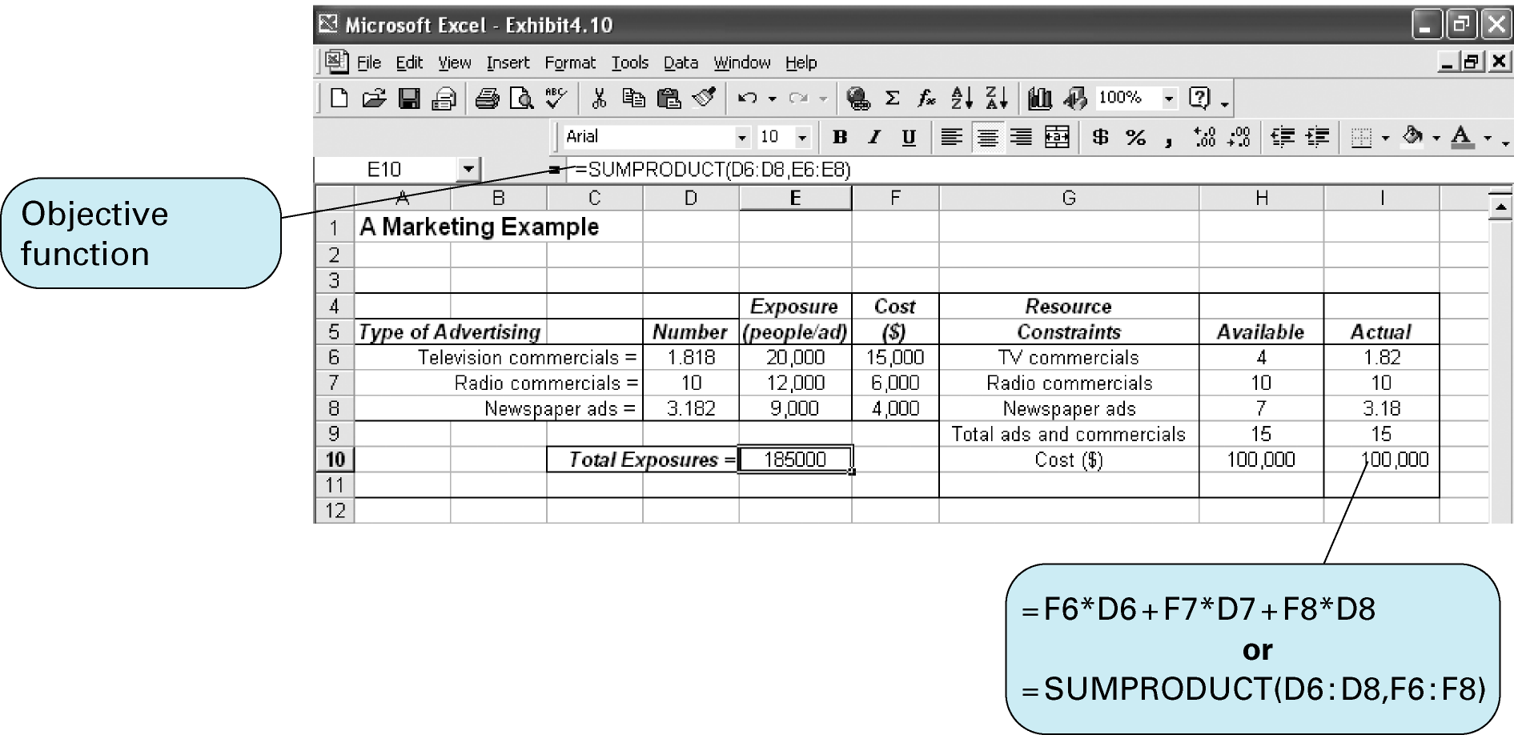

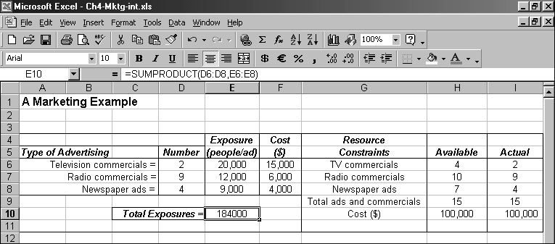

A Transportation Problem
Warehouse supply of TV Sets Retail store demand TV Sets:
1 - Cincinnati 300 A - New York 150
2 - Atlanta 200 B - Dallas 250
3 - Pittsburgh 200 C - Detroit 200
Total 700 Total 600

Minimize Z = $16x1A + 18x1B + 11x1C + 14x2A + 12x2B + 13x2C + 13x3A + 15x3B + 17x3C

subject to:

x1A + x1B+ x1C ≤ 300

x2A+ x2B + x2C ≤ 200

x3A+ x3B + x3C ≤ 200

x1A + x2A + x3A = 150

x1B + x2B + x3B = 250

x1C + x2C + x3C = 200

All xij ≥ 0

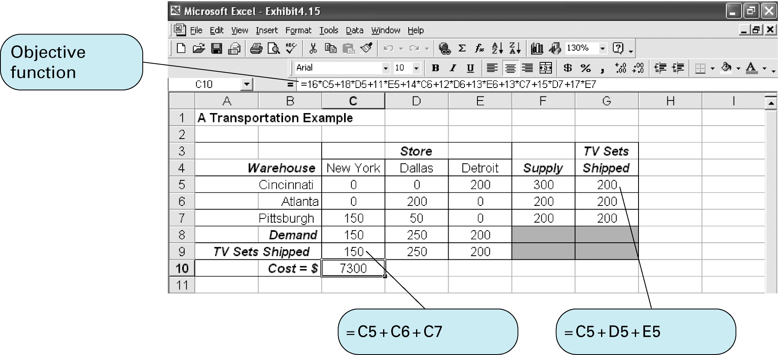

Blending Problem

Frederick's Feed Company receives four raw grains from which it blends its dry pet food. The pet food advertises that each 8-ounce can meets the minimum daily requirements for vitamin C, protein and iron. The cost of each raw grain as well as the vitamin C, protein, and iron units per pound of each grain are summarized on the next slide.

Frederick's is interested in producing the 8-ounce mixture at minimum cost while meeting the minimum daily requirements of 6 units of vitamin C, 5 units of protein, and 5 units of iron.

Vitamin C Protein Iron

Grain Units/lb Units/lb Units/lb Cost/lb

1 9 12 0 .75

2 16 10 14 .90

3 8 10 15 .80

4 10 8 7 .70

Define the decision variables

x_{j} = the pounds of grain j (j = 1,2,3,4)

used in the 8-ounce mixture

Define the objective function

Minimize the total cost for an 8-ounce mixture:

MIN .75x₁ + .90x₂ + .80x₃ + .70x₄

Define the constraints

Total weight of the mix is 8-ounces (.5 pounds):

(1) x₁ + x₂ + x₃ + x₄ = .5

Total amount of Vitamin C in the mix is at least 6 units:

(2) 9x₁ + 16x₂ + 8x₃ + 10x₄ > 6

Total amount of protein in the mix is at least 5 units:

(3) 12x₁ + 10x₂ + 10x₃ + 8x₄ > 5

Total amount of iron in the mix is at least 5 units:

(4) 14x₂ + 15x₃ + 7x₄ > 5

Nonnegativity of variables: x_{j} > 0 for all j

The Management Scientist Output

OBJECTIVE FUNCTION VALUE = 0.406

VARIABLE VALUE REDUCED COSTS

X1 0.099 0.000

X2 0.213 0.000

X3 0.088 0.000

X4 0.099 0.000

Thus, the optimal blend is about .10 lb. of grain 1, .21 lb.

of grain 2, .09 lb. of grain 3, and .10 lb. of grain 4. The

mixture costs Frederick’s 40.6 cents.

Portfolio Planning Problem

Winslow Savings has $20 million available for investment. It wishes to invest over the next four months in such a way that it will maximize the total interest earned over the four month period as well as have at least $10 million available at the start of the fifth month for a high rise building venture in which it will be participating.

For the time being, Winslow wishes to invest only in 2-month government bonds (earning 2% over the 2-month period) and 3-month construction loans (earning 6% over the 3-month period). Each of these is available each month for investment. Funds not invested in these two investments are liquid and earn 3/4 of 1% per month when invested locally.

Formulate a linear program that will help Winslow Savings determine how to invest over the next four months if at no time does it wish to have more than $8 million in either government bonds or construction loans.

Define the decision variables

g_{j} = amount of new investment in

government bonds in month j

c_{j} = amount of new investment in construction loans in month j

l_{j} = amount invested locally in month j,

where j = 1,2,3,4

Define the objective function

Maximize total interest earned over the 4-month period.

MAX (interest rate on investment)(amount invested)

MAX .02g₁ + .02g₂ + .02g₃ + .02g₄

+ .06c₁ + .06c₂ + .06c₃ + .06c₄

+ .0075l₁ + .0075l₂ + .0075l₃ + .0075l₄

Define the constraints

Month 1's total investment limited to $20 million:

(1) g₁ + c₁ + l₁ = 20,000,000

Month 2's total investment limited to principle and interest invested locally in Month 1:

(2) g₂ + c₂ + l₂ = 1.0075l₁

or g₂ + c₂ - 1.0075l₁ + l₂ = 0

Month 3's total investment amount limited to principle and interest invested in government bonds in Month 1 and locally invested in Month 2:

(3) g₃ + c₃ + l₃ = 1.02g₁ + 1.0075l₂

or - 1.02g₁ + g₃ + c₃ - 1.0075l₂ + l₃ = 0

Month 4's total investment limited to principle and interest invested in construction loans in Month 1, goverment bonds in Month 2, and locally invested in Month 3:

(4) g₄ + c₄ + l₄ = 1.06c₁ + 1.02g₂ + 1.0075l₃

or - 1.02g₂ + g₄ - 1.06c₁ + c₄ - 1.0075l₃ + l₄ = 0

$10 million must be available at start of Month 5:

(5) 1.06c₂ + 1.02g₃ + 1.0075l₄ > 10,000,000

No more than $8 million in government bonds at any time:

(6) g₁ < 8,000,000

(7) g₁ + g₂ < 8,000,000

(8) g₂ + g₃ < 8,000,000

(9) g₃ + g₄ < 8,000,000

No more than $8 million in construction loans at any time:

(10) c₁ < 8,000,000

(11) c₁ + c₂ < 8,000,000

(12) c₁ + c₂ + c₃ < 8,000,000

(13) c₂ + c₃ + c₄ < 8,000,000

Nonnegativity: g_{j}, c_{j}, l_{j} > 0 for j = 1,2,3,4

